Dear Students, participants and friends ! We would like to invite you to another
English and TEA meeting on Friday, 25th of May – Friday at 5.30 ROOM A
Speaker : Seweryn Brandau ( USA)

Topic: Brave New World: Future Trends, Globalisation and Things Unforeseen

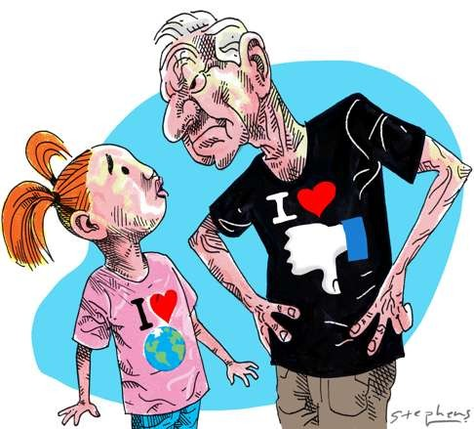
Please confirm your attendance by 24 of May by mail elc@us.edu.pl or phone 32 359 22 11
Address: Uś , Bankowa 14 . room 505

